**Model Development Phase Template**

|  |  |
| --- | --- |
| Date | 15 July 2024 |
| Team ID | team-740084 |
| Project Title | Online Payments Fraud Detection |
| Maximum Marks | 10 Marks |

**Initial Model Training Code, Model Validation and Evaluation Report**

The initial model training code will be showcased in the future through a screenshot. The model validation and evaluation report will include a summary and training and validation performance metrics for multiple models, presented through respective screenshots.

**Initial Model Training Code (5 marks):**

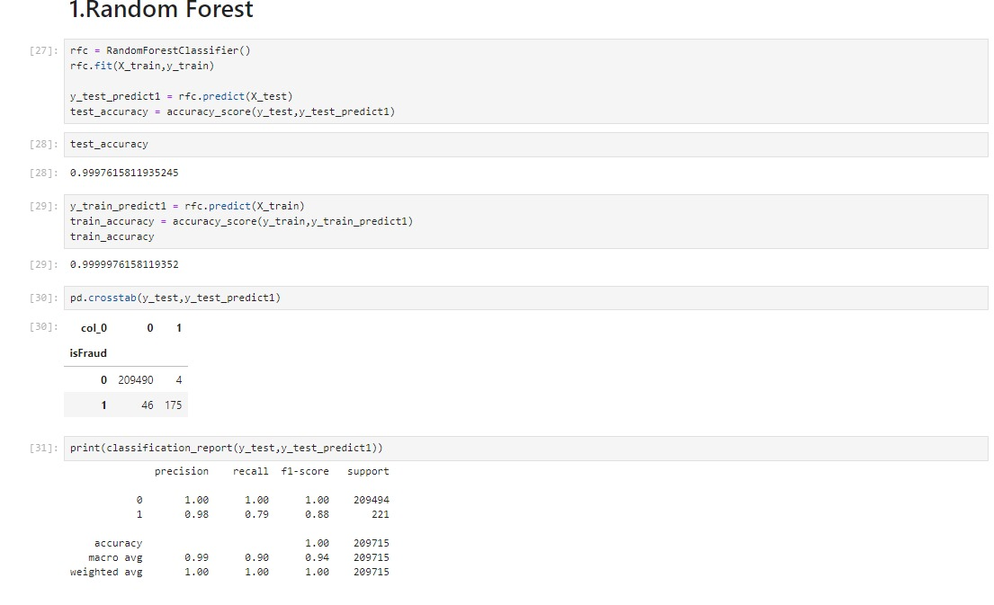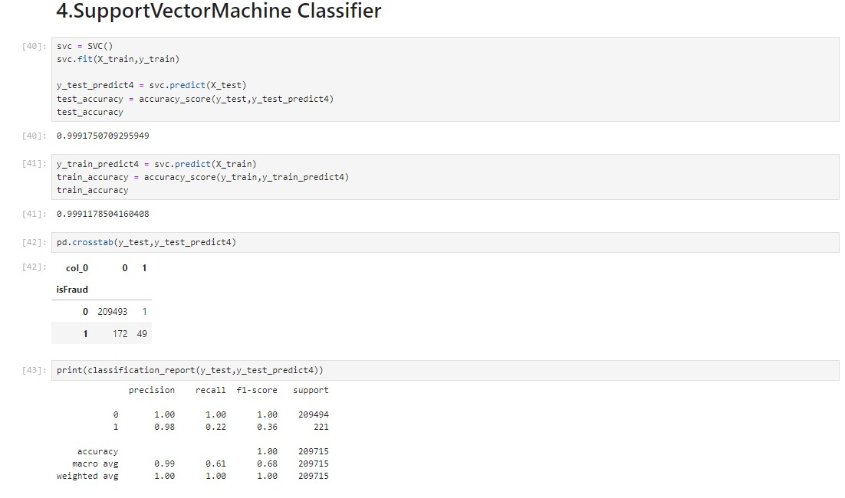

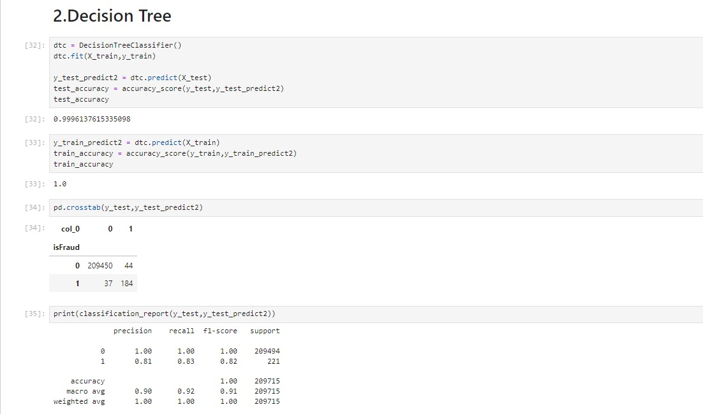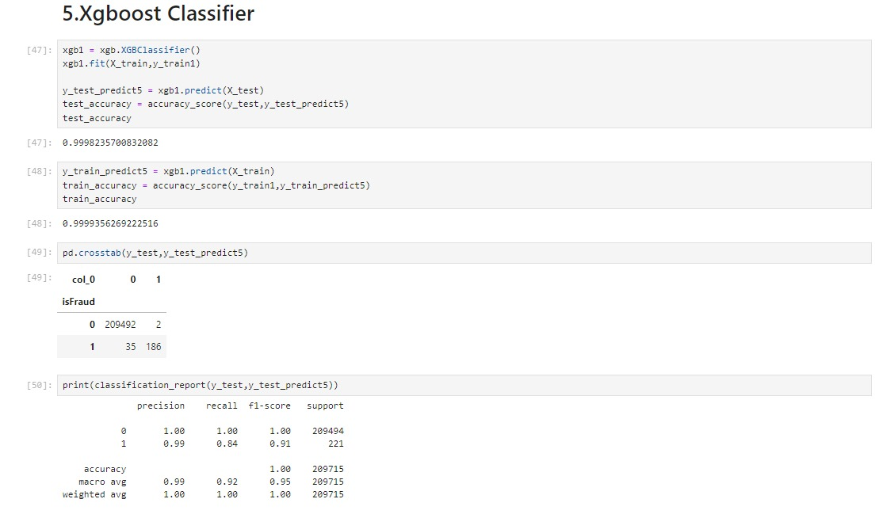

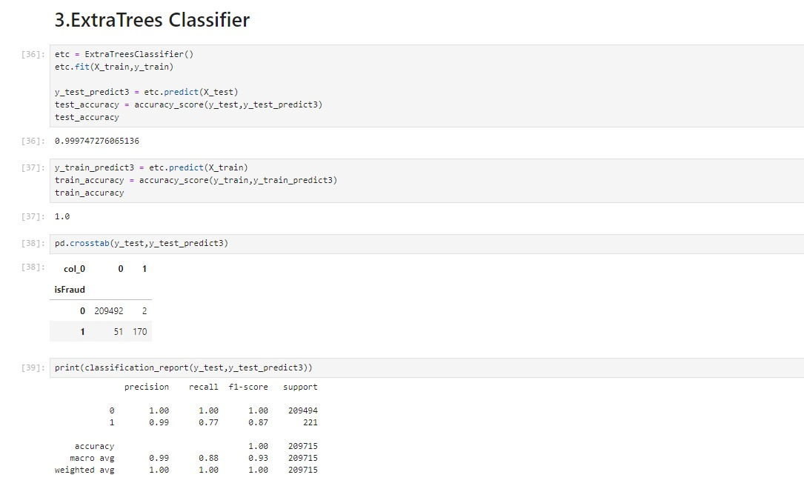

**Model Validation and Evaluation Report (5 marks):**

|  |  |  |
| --- | --- | --- |
| **Model** | **Summary** | **Training and Validation Performance Metrics** |
| Random Forest classifier | cs26 | cs26 |
| Decision Tree classifier | cs27 | cs27 |
| ExtraTrees classifier | cs28 | cs28 |
| Support Vector Machine Classifier | cs29 | cs29 |
| Xgboost Classifier | cs31 | cs31 |